**Class Activity – Lesson 13**

1. Did you attend class today (6 pts)
2. Were you on time to class today (4 pts)?
3. Just suppose you wanted to test to see if men or women do better on statistics final. You randomly choose 50 students from each gender. Would you be doing an independent-samples test or a matched-pair test (1 pt)? **Independent Samples test**
4. Just suppose you wanted to test to see if students’ score improve from a pre-test to a statistics final. You random choose 100 students and get both measurements. You randomly choose 50 students from each gender. Would you be doing an independent-samples test or a matched-pair test (1 pt)? **matched-pair test**
5. Use the heart rate data from class survey to compare the mean heart rates of males and females. Please answer the following questions
6. (1 pt)Why are the two samples of heart rate data (males and females) independent?

**How the sample of women was collected is independent of how the sample of men was collected.**

1. (1 pt)Find and interpret the 95% confidence interval of the difference in the true mean heart rates between males and females?

**We are 95% confident that the true difference of the means is between -0.897 and 7.064. (Note: you could have the numbers switched if the Males were group 1 and Females were group 2)**

(c) (1 pt)Is there a difference in the mean heart rates between the two genders? Why?

**We cannot detect a difference since zero is in the confidence interval.**

1. A crackerjack statistics student in Brother Cromar’s class claims that the mean heart rates between males and females at BYU-I are different. You assume that the class survey gathered at the beginning of the semester is a random sample of the BYU-I population and you use a level of significance (α=0.05).
2. (1 pt)State the null and alternative hypothesis for this study.

**Ho:µ1= µ2 Ha:µ1≠ µ2**

1. (1 pt) Show the descriptive statistics (both numerical and graphical) for this procedure.

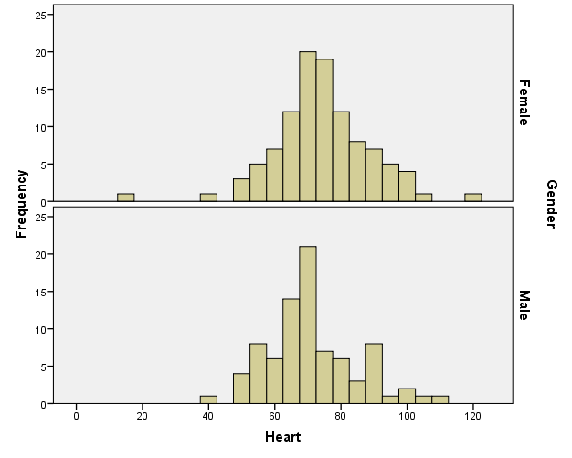

**Female Mean=74.48 Std. Dev.= 14.488**

**Male Mean=71.40 Std. Dev.= 13.171**

1. (1 pt)Check the requirement that the distribution of sample means is bell-shaped.

**Since the sample sizes are large for both female and male samples, we can assume that the distributions of sample means from both genders are bell-shaped. Why? The Central Limit Theorem**

1. (1 pt) What is the Test Statistic? **1.528** **(Note: you could have a negative number if the Males were group 1 and Females were group 2)**
2. (1 pt) What are your degrees of freedom? **182.821**
3. (1 pt) What is the P-value? **0.128**
4. (1 pt)What decision do you make about the null hypothesis based on the decision rule?

**Since the p-value is greater than alpha, we don’t reject the null hypothesis.**

1. (1 pt) State your conclusions in “layman’s terms”.

**We have insufficient evidence to say there is a difference in the true mean heart rates between men and women**.